April 21, 2013 – 4th Sunday of Easter
© Jean E. Mornard

I saw another funny cartoon on Facebook yesterday.
[DESCRIBE]

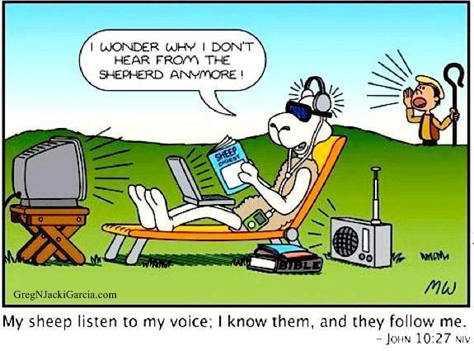

Three of our four readings today have to do with the Lord as our shepherd. They're familiar and beloved texts and are very comforting to us in times of stress or trouble. They speak of the care that a shepherd takes of his flock – of feeding them and leading them to water, of tending their hurts, and of wiping away their tears. These all are beautiful words describing the love that God has for us, his people.

Or they would be, if we could hear them. How many of us actually take time to listen to our Shepherd's voice? How many of us automatically know that voice when we hear it?

This past week has been an emotional roller coaster, especially for the people of Massachusetts, and through the sometimes dubious magic of 24-hour news reporting and Facebook, for the rest of us, too. After the bombs detonated in Boston last Monday, the news outlets filled the airwaves with speculations and commentary, even when details were scarce. Everyone wanted to weigh in with their personal slant on the event.

One new source broadcast some premature and ultimately incorrect information, claiming it was an exclusive. When they figured out they were wrong, rather than issue a correction and move on, they spent the better part of an hour discussing their error and the different sources from which they got it, as if THAT were the news.

It must be the work of terrorists! It was probably Muslims! But what did they want – does anybody know? Aren't Bostonians wonderful people – look at how many ran into danger to help! Wait! We've got suspects! Who are they? Wait! We know who they are! They ARE Muslims! But they're so young! Omigosh, a cop has just been killed in Cambridge! Wait! It was the terrorists! But how could they do this? They're so young! Holy Cow! There's a shootout happening in Watertown! In WATERTOWN! There aren't shootouts in Watertown!

They must have been framed. Al Quaeda must be behind it! It's unbelievable - they're throwing bombs out the car windows as the police chase them! But they seemed like such nice boys! Wait! One of the terrorists has been killed. Where's the other one? He's only 19! They must have been set up! They've shut down the entire city of Boston! Rush hour has never been this quiet in BOSTON! Wait! They've found him. In a BOAT? They're sending in the high tech toys now! Wait, wait, wait! They've GOT him! Whew! We can all sleep easier in our beds now!

It was exhausting. And though the marathon bombings and subsequent manhunt were no doubt the most prominent event this week, there was also an explosion, an earthquake, a wildfire, poison laced letters, and increased tensions all around the world, all of which were covered in great detail when reporters were taking a break from the bombings.

How can anyone expect to hear anything through that noise, much less the still, small voice of God?

Listen to the 23rd Psalm again.

The LORD is my shepherd; *
I shall not be in want.

He makes me lie down in green pastures *
and leads me beside still waters.

He revives my soul *
and guides me along right pathways for his Name's sake.

Though I walk through the valley of the shadow of death,
I shall fear no evil; *
for you are with me;
your rod and your staff, they comfort me.

You spread a table before me in the presence of those who trouble me; *
you have anointed my head with oil,
and my cup is running over.

Surely your goodness and mercy shall follow me all the days of my life, *
and I will dwell in the house of the LORD forever.

It's like sunshine on your face after a storm, or that special warm breeze that lifts your spirit and makes you feel weightless. You can almost imagine yourself in a bubble of protection and well-being. This is the kind of life that God wants for us. Not a life filled with stress and anxiety and violence and tension.

We are all walking through the valley of the shadow of death these days, it seems. There's a popular idiom about today's news – if it bleeds, it leads. It seems that we are a culture that is steeped in violence and fear.

Look at the gun control debate. No matter which side you take in the issue, all you hear about is fear – fear that the government is going to take away our rights and declare martial law, fear that more and more people are going to be killed by more and more powerful guns, and fear that if we don't all have guns that we will all be killed by criminals who DO have guns.

I'm not going to weigh into that debate, but I do wonder what the argument would sound like if all of the fear were taken out of it. Or if all of the sides were listening to the Shepherd's voice instead of shouting over each other and trying to score political points.

And I wonder what any of this has to do with those still waters, those right pathways, and that table spread in the presence of those who trouble us.

So what's wrong with us, with society? Don't the comforting words of the psalm and the Gospel sound better than fear and violence? Wouldn't it be nice to just relax beside that flowing water and eat the nice picnic that God provides for us? Of course it would! So why can't we get there?

Personally, I blame the Enlightenment. That's my stock answer for the ills of the world today. The Enlightenment was an intellectual movement that stressed reason, thought, and the power of the individual, rather than faith and tradition, to be able to solve the world's problems.

Don't get me wrong – a lot of what is good about our world today came out of this movement. I personally would not want to give up antibiotics, novocaine, electricity, and indoor plumbing, to name a few.

But a lot of ill has come of it, too. The idea that we don't have to be dependent on anyone but ourselves has led naturally to feeling like we no longer have to be dependent on God either. I imagine the comfort and security offered by Psalm 23, or the idea that we were sheep in need of a shepherd, might have been repugnant to some of the Enlightenment's great thinkers.

And the notion of individual rights, which forms the backbone of our Constitution, has given rise to a cult of individualism that leaves little room for a community – even one such as the Body of Christ. But the freedom of the individual offers a false refuge. We need each other, and we need God. Now more than ever. And we need to be able to hear him over the chaos and noise.

Not to sound gloomy, but in a way we've been set up to fail at this. We live in a dangerous world, even with all our advances. And because of those advances, especially in communications, we get to witness just how dangerous it is 24 hours a day, if we want to. And the result of this is that everyone lives their lives in fear.

But we don't have to. We have a remedy. As it says in First John, "There is no fear in love, but perfect love casts out fear." God's love for us, the love of a shepherd for his sheep, the love of a father for his children, is that perfect love. And as Paul says in his letter to the Romans, nothing in all creation can separate us from the love of God in Christ Jesus our Lord.

Rest assured, God hasn't gone anywhere and he hasn't gone silent. Take a minute, or maybe even a whole day, to unplug and listen to him speaking to you. Don't listen to the fear or the anger, but listen to the voice of that perfect love that leads us beside the still waters. There is rest and peace there for us all.

Amen.

