August 25, 2013 – 14th Sunday after Pentecost (Proper 16)
© Jean E. Mornard

When I was a teenager I read a lot of science fiction. One book that I read several times was Robert Heinlein’s A Stranger in a Strange Land. It’s funny how some things in books you like stick with you over the years. One such thing in A Stranger in a Strange Land was the description of a piece of sculpture by Rodin. Unlike today, back in those days you couldn’t just Google something to see what it really looked like, so it was a long time before I actually saw this particular piece.

The name of the sculpture is The Fallen Caryátid Carrying Her Stone. In Greek architecture, a caryátid is a statue of a woman that is used as the base for a pillar. In Rodin’s version, the pillar, or maybe even the whole building, has collapsed and the poor caryatid is almost crushed under the stone she is still trying to support. She has no hope of being relieved of her life’s burden, and it’s killing her, but her face appears determined and uncomplaining.

Today’s Gospel reminded me of that sculpture, which I finally got to see in person at the Metropolitan Museum of Art in New York. As Jesus is teaching in a synagogue one Sabbath, a woman appears who is bent over double. The text said that she was bent over by a spirit, but we’ve all seen people who are so burdened by life that they can no longer stand up straight. All they can do is look down at the ground and shuffle along as best as they can.

We don’t know if this woman came into the synagogue hoping to see Jesus and be healed of her burden. The text doesn’t say if this was one of the towns that was visited by the emissaries whom Jesus sent ahead of him, and if it was, it doesn’t explain why this particular woman was not cured by those emissaries.

There is an awful lot left to our imagination. In fact, this might be merely a rhetorical tool on Luke’s part to facilitate the discussion about Jesus healing on the Sabbath. But I think to do so cheapens this woman’s misfortune, and I want to stick with her for awhile.

What do we know about her? Not much. We know that she has had this affliction that has caused her to be bent over double for 18 years. And we can probably assume that she is a person of faith, since she showed up in the synagogue on the Sabbath.

That’s about it. We don’t know how she got that way. Was she old, with, terrible osteoporosis? I think we have all probably seen elderly people who are bent over like that. Had she been in an accident, which crushed her spine down in some way? Was she a young woman, who was born that way through some genetic anomoly? Or was she, in fact, possessed by a demon, as the text says?

We can certainly surmise what she had suffered by her affliction. She must have been in terrible pain, in her back, and her legs, and maybe even her arms and shoulders, if she was using a stick to walk as she is usually portrayed in religious art. She would have probably been considered ritually unclean, as all sick people were. In Judaism of Jesus’ time, illness or disability were considered to be punishment by God for sins committed by that person or their family.

And she couldn’t pray. Bowing did occur once in awhile why praying, but most Jewish prayers were said either standing or sitting upright. It was especially important to stand out of respect while reciting the Shema, which is one of the most important of all Jewish prayers. But this poor woman couldn’t even say the most basic prayers in the traditional way. After 18 years, it must have cost her a lot to even enter the synagogue.

What was she looking for? Why was she there? Did she regularly come there to try to pray, despite her condition? Had she heard of Jesus and was hoping for a miracle? Or maybe was she merely hoping to use the distraction of the famous travelling preacher in order to avoid being shooed away from the synagogue that morning.

We don’t know because she doesn’t say a word. But Jesus saw her and reached out to her. He called her into the center of the room where he was sitting to teach. And then he reached out again, to lay his hands on her. Interestingly, he pronounced her to be healed before he touched her, as if the very act of her bravely stepping up brought about the healing. And the first thing she did was to stand up straight and glorify God. At last! Or since this Wednesday marks the 50th anniversary of Martin Luther King Jr.’s “I have a dream” speech, maybe it should be, “Free at last, free at last! Thank God Almighty, I’m free at last!”

Usually, when this passage comes around, or ones like it, a lot of people want to talk about whether or not Jesus broke the Torah by healing on the Sabbath. There are endless rounds of arguments, at least in Church geek circles. “Does Jesus healing on the Sabbath mean we, too, can ignore the Torah?” Didn’t Jesus say he came to abolish the old law? No, he didn’t – he came to fulfill it. Well, it’s the same thing, right? No it’s not! Yes it is! Whatever!”

Those are important discussions to have – well, some of them at least. And it’s a perfectly valid thing to consider with this text. But I love the human element of this passage. Luke describes this poor woman so vividly, and she has such a happy ending. Sabbath or no, she was weighed down with an almost impossible burden, like the caryátid fallen under her stone, and she was set free.

In several parables and Gospel stories Luke talks about the dangers of distraction. What could be more distracting than a crushing burden? I'm sure most of us have had to bear the weight of a terrible problem or difficulty at one time or another, either physical, mental, or emotional. They tend to consume our every waking moment, and sometimes cause even more waking moments because they keep us from being able to sleep.

And the worst burdens are the ones we bear alone – the secret burdens. Carrying a secret burden is the hardest thing in the world to do. It saps your strength. It fills you with a terrible loneliness. And that loneliness leads to despair, which can crush your soul.

But who hasn't felt the wonderful relief of sharing a burden, even with just one other person? Who hasn't felt the weight taken off their shoulders as That other person helps put it in proper perspective? Because, of course, a secret burden keeps growing and growing, and sooner or later, guilt sets in, adding even more weight until we're completely crushed, just like that poor caryátid under her stone.

Sometimes, though, we really feel like we can't share our burdens with anyone. Sometimes there's shame involved, or fear. Sometimes we can't even articulate them to ourselves, much less to someone else. At those times, or at any time, really, it's good to remember that God is always there to listen, and to share our burdens. As Jesus said in Matthew 11:28, "Come to me, all you who are weary and burdened, and I will give you rest."

There's a comic strip on the internet that I love called, "Coffee with Jesus." The premise is that Jesus is here in modern times, and meets people at the local coffee house to talk. Yesterday's strip was called Another Chore and in it Jesus talks about how we put "spending time with God" on our to-do lists as just another chore, just another burden. The punch line is Jesus saying, "I don't want to be another chore. Let me be your coworker."

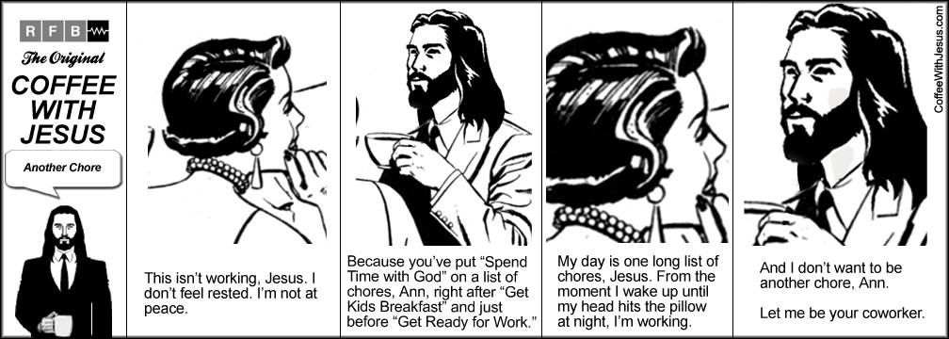

I want to talk for a minute about the Sacrament of Reconciliation. It used to be called Confession, but that's too narrow a focus for one of the most important rites in our tradition. This is more than just confessing wrongdoing, although that's part of it. It's about sharing our burdens. It's about getting relief from the crushing distraction of those things that are weighing on our soul.

I strongly encourage you all to read through the Sacrament of Reconciliation, starting on page 446 of the Book of Common Prayer. I have to confess (no pun intended) that I used to be wary of this sacrament, but I have since come to view it as one of the most powerful and transformative things that we do in the Church. Just the mere act of sharing our burdens with God makes them lighter for us.

If this sacrament is something you feel you would benefit from, by all means use it. But at the very least, tell your burdens to God. Share your yoke with Jesus. When he says "Take my yoke upon you…for my yoke is easy and my burden is light," he IS asking us to share his burdens of caring for the poor and spreading the Gospel, but at the same time, he is offering to shoulder our burdens, too. Yokes are carried by two, and they make the burdens lighter for both.

The woman in today's Gospel was bent over under a terrible burden, but she took her burden into Jesus' presence and he healed her. He lifted the burden off of her shoulders with a word and a touch. Let him do the same for you.

Amen.

